Intelligent Radio Resource Allocation for 5G Traffic using Federated Deep Reinforcement learning with Long Short-Term Memory

Sai Haritha Akella
Dept. of Electronics and Communication Engineering, SRM Institute of Science and Technology
Kattankulathur, Chengalpattu
sa4288@srmist.edu.in

Aditya Konwar
Dept. of Electronics and Communication Engineering, SRM Institute of Science and Technology
Kattankulathur, Chengalpattu
ak0141@srmist.edu.in

Dr. R Dayana
Dept. of Electronics and Communication Engineering, SRM Institute of Science and Technology
Kattankulathur, Chengalpattu
dayanar@srmist.edu.in

Aashi Agarwal
Dept. of Electronics and Communication Engineering, SRM Institute of Science and Technology
Kattankulathur, Chengalpattu
aa2140@srmist.edu.in

Abstract- Recent 5G networks support diverse slice services such as eMBB, URLLC, and mMTC, each with different Quality of Service (QoS) requirements. Traditional radio resource management (RRM) approaches struggle to handle dynamic traffic, interference and changing channel conditions. To address this issue, this paper proposes an intelligent and adaptive resource allocation framework for solving this issue. The proposed system uses an LSTM model to predict traffic demand across network. A federated multi-agent DDQN-based reinforcement learning approach is then applied for distributed resource allocation. Simulation results show improved performance with higher throughput (83.94%), lower latency (30.84%), and better packet loss, energy efficiency, and fairness, demonstrating the effectiveness of AI-based RRM for future wireless networks.

I. INTRODUCTION
The latest evolution of 5G enables services such as eMBB, URLLC, and mMTC to operate within the same network, with different QoS needs in each of them. eMBB focuses on high throughput, URLLC requires ultra-low latency and reliability, and mMTC supports large-scale IoT connectivity. These requirements make Radio Resource Management (RRM) more challenging, especially under dynamic traffic and channel conditions where traditional scheduling methods are not enough [1] [2] [3].

To address the following issues, 5G introduces network slicing and flexible RAN scheduling, where Physical Resource Blocks (PRBs) are dynamically assigned to different slices. However, prioritizing URLLC traffic without proper management can reduce eMBB performance, making it balanced and intelligent scheduling necessary [1] [4]. Developing adaptive resource allocation methods which optimizes throughput, latency, and reliability remains a key challenge.

AI and machine learning techniques have shown promise in improving RRM. LSTM models can predict traffic patterns for proactive allocation [5] [6] while GNNs capture spatial interference and network topology for coordinated optimization [7] [8]. DRL methods further support adaptive decision-making in dynamic environments [9] [4].

However, centralized learning approaches face privacy and scalability issues. Federated learning allows collaborative training without sharing raw data, improving privacy and reducing communication overload [10] [9]. To address these challenges, this work proposes a slice-aware RRM framework that integrates LSTM-based traffic prediction, GNN-based topology modelling, and federated multi-agent DDQN learning to support efficient and adaptive resource allocation in dynamic 5G networks [11] [8].

II. SYSTEM MODEL

In our proposed system we presented an intelligent radio resource management (RRM) framework for 5G networks which supports all three current slices. It combines traffic prediction, spatial learning, and reinforcement learning to learning to facilitate adaptive resource allocation under dynamic conditions. A 5G environment is simulated on Ubuntu to get the generated data where it then undergoes preprocessing via Python to construct a dataset encompassing key parameters: packet size, latency, throughput, SINR, and queue length. This dataset, by optimizing throughput, latency, dependability, and fairness across network slices, supports proactive scheduling decisions.

Now for the proposed architecture, the network state is defined using traffic characteristics, QoS requirements, and channel conditions. A Graphic Neural Network captures spatial relationships and interference among users.
The data generated and its insights are as follows:
- The eMBB slice's highest throughput (150.65 Mbps) and largest average packet size (1247.83 bytes) indicates video streaming and other bandwidth-intensive applications. However, it has the highest burstiness index (8.74) and a substantial delay (35.82 ms) because to burst-driven high-data transmissions.
- URLLC traffic is adjusted for low latency, with a reasonable throughput of 85.46 Mbps and a significantly lower latency of 2.99 ms. Due to its fast packet rate (114.33 pkts/s) and smaller packet sizes (354.14 bytes), URLLC can manage
- frequent, delay-sensitive conversations. Its lower burstiness index (6.71) indicates better controlled traffic patterns that satisfy reliability and real-time communication requirements.
- However, because to its modest speed (11.97 Mbps) and short packet sizes (125.66 bytes), mMTC traffic is suitable for Internet of Things type connections. It has the lowest burstiness (2.65) and can tolerate a longer delay (54.54 ms) despite having the same packet rate, suggesting less issues and consistent traffic patterns. Because of these unique features, slice-aware resource allocation techniques are necessary to effectively manage a variety of 5G traffic demands.

The first stage of the proposed model uses a Graph Neural Network (GNN) to capture how users are connected and how they interfere with each other in the network. Since resource allocation is influenced by these interactions, the GNN helps understand the spatial relationships and overall network structure. It then extracts meaningful spatial features that represent the current topology and interference conditions, which are passed to the next stage of the model for further processing.

In the next stage, a Long Short-Term Memory (LSTM) network is used to predict future traffic throughput by learning patterns from past data. The input consists of sequential network parameters such as SINR, resource block (RB) allocation, packet size, and delay. These inputs are first organized into fixed-length sequences (e.g., 20-time steps), allowing the model to capture short-term traffic trends instead of relying on single observations. This sequential approach helps the system understand how network conditions evolve over time, which is important in dynamic 5G environments. The processed sequences are then fed into an LSTM layer with 128 units, which uses memory cells and gating mechanisms to retain relevant past information while modeling temporal variations. The output is passed through a dense layer to predict the next-step throughput. This predicted value enables the system to make proactive and slice-aware resource allocation decisions, improving overall network performance under changing conditions.

The proposed algorithm that is the Federated Deep Reinforcement Learning (FDRL) shows the distributed and private resource allocation over many 5G slices without sharing raw data. Several agents perform local learning and periodically aggregate model parameters to achieve coordinated optimization. This decentralized framework is perfect for multi-slice systems such as eMBB, URLLC, and mMTC, where independent network parts must cooperate while making scalable judgments. The framework collects slice-specific network states, including traffic demand, resource block availability, queue status, and SINR. These slice-level observations are aggregated while retaining slice awareness and sent to a Slice-Aware Double Deep Q-Network (DDQN) agent. This DDQN agent approaches an adaptive and effective slice-aware resource allocation mechanism for next-generation networks through ongoing feedback and parameter modifications.

The double Q-learning enables the agent to selects the optimal scheduling and resource block allocation actions with the goals of maximizing throughput for eMBB, reducing latency for URLLC, and efficiently utilizing resources for mMTC. Following resource allocation, the performance metrics generated by the environment, including realized throughput and latency, are used to compute a QoS-aware reward function. The reward considers throughput performance, delay penalties, and resource consumption cost in order to align the learning with the principles of 5G QoS differentiation. Thus, the model learns effectively from continuous feedback, allowing it to refine its decision its decision-making process and deliver improved performance in terms of throughput, latency and Qos satisfaction.

- Slice Traffic Prediction and Topology Modeling

Long Short-Term Memory (LSTM) networks are used to predict future traffic demands for each network slice in order to improve proactive resource allocation.
For the given historical traffic data $H_{t}$, the predicted load for the next time step is:

$${\hat{λ}}_{s}(t+1)=f_{LSTM}(H_{t})$$ (1)
Here:
- ${\hat{λ}}_{s}(t+1)$represents the predicted traffic load of slice $s$at the next time step.
- $f_{\text{LSTM}}$denotes the LSTM model used for prediction.
- $H_{t}$is the historical traffic data up to time $t$.

Anticipatory resource scheduling prior to congestion is made possible by this prediction.

Graph Neural Networks (GNNs) are also used to design the spatial linkages between base stations and interference interactions. Let 𝐴 be the adjacency matrix characterizing network connection, and let 𝑋 represent node attributes that describe base station load and channel conditions. The definition of the graph convolution operation as:
$$X^{'}=σ(\hat{A}XW)$$ (2)
Where:
- $X^{'}$is the updated node feature matrix after convolution.
- $\hat{A}$represents the normalized adjacency matrix, describing how base stations are connected.
- $X$is the input node feature matrix, containing features like load and channel conditions.
- $W$denotes the learnable weight parameters of the model.
- $σ$is a nonlinear activation function applied after aggregation.

where $W$denotes learnable parameters and $σ$is a nonlinear activation function. The GNN captures spatial correlations to enable coordinated multi-cell optimization.
Table 1: Abbreviations Used in the Paper
Abbrev | Meaning | Abbrev | Meaning
5G | Fifth Generation Network | QoS | Quality of Service
RRM | Radio Resource Management | RAN | Radio Access Network
AI | Artificial Intelligence | IoT | Internet of Things
LSTM | Long Short- Term Memory | GNN | Graph Neural Network
DRL | Deep Reinforcement Learning | DQN | Deep Q-Network
DDQN | Double Deep Q-Network | FDRL | Federated Deep Reinforcement Learning
PRB | Physical Resource Block | SINR | Signal-to-Interference-plus-Noise Ratio
eMBB | Enhanced Mobile Broadband | URLLC | Ultra-Reliable Low Latency Communication
mMTC | Massive Machine Type Communication | PCA | Principal Component Analysis
RMSE | Root Mean Square Error | MAE | Mean Absolute Error
k-NN | k-Nearest Neighbor | RB | Resource Block

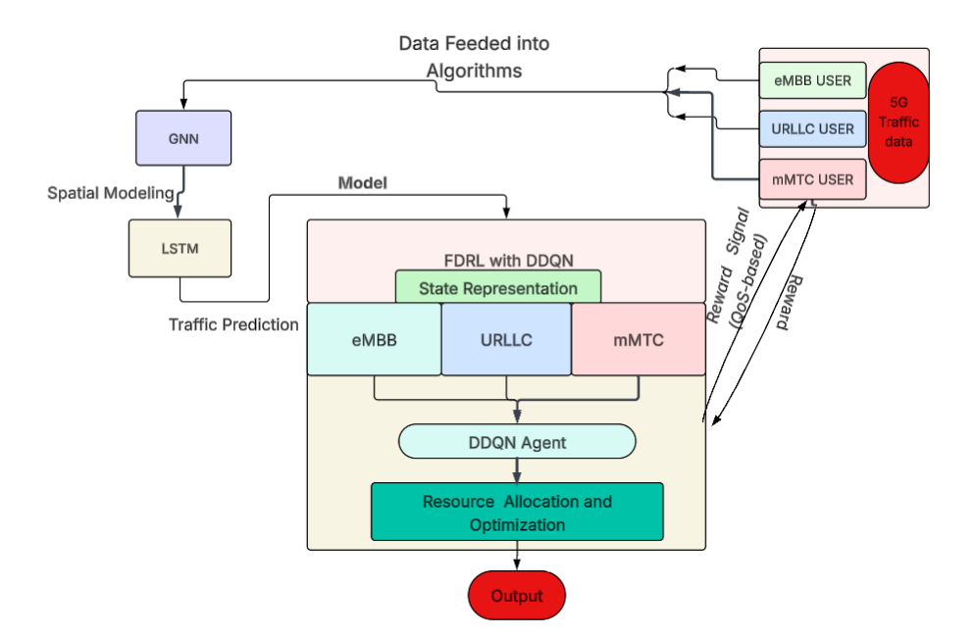

Figure 1: Architecture of the Proposed model

B. Deep Reinforcement Learning Model

The main objective of reinforcement learning is to learn an optimal action that maximizes expected cumulative reward. The action-value function is expressed as:

$$Q_{π}(s,a)=E[G_{t}∣s,a]$$ (3)
Where:
- $Q_{π}(s,a)$represents the expected return when taking action $a$in state $s$under policy $π$.
- $G_{t}$is the cumulative future reward starting at time $t$.
- $s$denotes the current state of the environment.
- $a$ is the action chosen by the agent.

The optimal Q-function satisfies the Bellman optimality equation:
$$Q^{*}(s,a)=E[r+λ\underset{a^{'}}{max⁡}Q^{*}(s^{'},a^{'})]$$ (4)
Where:
- $Q^{*}(s,a)$is the optimal Q-function.
- $r$represents the immediate reward received after taking action $a$.
- $γ$(Gamma) is the discount factor, controls the importance of future rewards.
- $s^{'}$is the next state after taking action.
- $a^{'}$represents possible future actions.

Due to large state and action spaces, Deep Q-Networks (DQN) are employed to approximate the Q-function:

$$Q(s,a;ω)$$ (5)
Here:
- $Q(s,a;ω)$is the approximated Q-value using a neural network.
- $ω$represents the neural network parameters (weights).

where $ω$represents neural network parameters.
The loss function used during training is:

$$L(ω)=E[(y-Q(s,a;ω))^{2}]$$ (6)
Where:
- $L(ω)$is the loss function used to update the network.
- $y$is the target value.
- The expression measures the difference between predicted and target Q-values.

where the target value is:

$$y=r+λ\underset{a^{'}}{max⁡}Q(s^{'},a^{'};ω^{-})$$ (7)
Where:
- $ω^{-}$represents the parameters of the target network, which are updated less frequently.
- $r$, $γ$, $s^{'}$, and $a^{'}$retain their earlier meanings.

C. Double Deep Q-Network Enhancement

DQN often gets affected by overestimation bias due to the use of a single network for action selection and evaluation. To address this issue, Double Deep Q-Networks (DDQN) are employed. The DDQN target value is computed as:

$$y=r+λQ(s^{'},argmax_{a^{'}}Q(s^{'},a^{'};ω);ω^{-})$$ (8)
Where:
- The action selection ($arg⁡{max⁡}_{a^{'}}Q(s^{'},a^{'};ω)$) is done using the main network.
- The evaluation of that action is done using the target network $ω^{-}$.This separation improves training stability and reduces overestimation errors.

By separating the action selection and evaluation processes, DDQN improves stability and convergence during training.

D. Federated Learning-Enabled Distributed Training

To preserve the privacy and reduce centralized data transmission, federated learning is integrated into the DRL framework. Each base station trains a local model using its own data. Local parameters $ω_{i}$are periodically uploaded to a central aggregation server.
The global model is updated as:

$$ω_{g}=\frac{\sum_{i=1}^{K}{η_{i}}ω_{i}}{\sum_{i=1}^{K}{η_{i}}}$$ (9)
Where:
- $ω_{g}$is the global model parameter set.
- $ω_{i}$represents the local model parameters from node $i$.
- $η_{i}$denotes the number of training samples used at node $i$.
- $K$is the total number of participating nodes (base stations).

where $η_{i}$denotes the number of samples used in local training. The updated global model is redistributed to all participating nodes for further training.

Algorithm 1. Slice-Aware Federated DDQN Resource Allocation Framework

Initialize:

1: Initialize LSTM traffic prediction model parameters $θ_{LSTM}$
2: Initialize GNN topology model parameters $θ_{GNN}$
3: Initialize main DDQN parameters $ω^{m}$
4: Initialize target DDQN parameters $ω^{r}$
5: Initialize global federated model parameters $ω^{g}$
6: Initialize replay buffer $D$, learning rate $α$, discount factor $λ$
7: Initialize maximum training episodes $E_{max}$, time steps $T_{max}$, and aggregation rounds $K$
8: Predict slice traffic demand using LSTM
$${\hat{λ}}_{s}(t+1)=f_{LSTM}(H_{t})$$
9: Update traffic load feature in state vector
10: Apply GNN to capture spatial interference
$$X^{'}=σ(\hat{A}XW)$$
11: Update coordinated multi-cell network features
12: for time step $t=1:T_{max}$do
13: for each agent $i=1:N$do
14: Observe state $s_{t}^{i}$
15: Select action $a_{t}^{i}=\{ϕ_{i,k},P_{i}\}$using ε-greedy policy
16: Execute slice-aware scheduling
• URLLC mini-slot priority
• eMBB adaptive allocation
17: end for
18: Environment returns reward
19: Observe next state $s_{t+1}$
20: Store experience tuple
$\left(s_{t} , a_{t} , r_{t} , s_{t+1}\right)$ into replay buffer $D$

Algorithm 2. DDQN Training Step

1: Sample mini-batch from replay buffer
2: Compute target value using DDQN:
$$y=r+λQ(s^{'},argmax_{a^{'}}Q(s^{'},a^{'};ω^{m});ω^{r})$$
3: Update main network weights:
$$ω^{m}=ω^{m}+α(y-Q(s,a;ω^{m}))∇Q$$
4: Minimize loss:
$$L(ω^{m})=E[(y-Q(s,a;ω^{m}))^{2}]$$
5: Soft update target network:
$$ω^{r}=τω^{m}+(1-τ)ω^{r}$$
6: end for (time step loop)
7: end for (episode loop)
8: for round k = 1 to K do
9: Each agent uploads local model $ω_{i}$
10: Aggregation server computes global model:
$$ω^{g}=\frac{\sum_{i=1}^{N}{η_{i}}ω_{i}}{\sum_{i=1}^{N}{η_{i}}}$$
11: Broadcast updated global model to all agents
12: end for (federated round loop)

Algorithm 1 describes the overall slice-aware federated DDQN resource allocation process. The model parameters for LSTM, GNN, and DDQN are first initialized. At each time step, the LSTM predicts future traffic demand, while the GNN captures spatial interference and network structure to enhance the system state. Based on this state, each agent selects channel and power allocation actions using an ε-greedy policy. URLLC traffic is given priority, and the remaining resources are allocated to eMBB. The system then receives a reward and stores the experience in a replay buffer for training. Algorithm 2 explains the learning and federated aggregation process. A mini-batch of experiences is sampled from the replay buffer to compute the DDQN target value, helping reduce overestimation. The main network is updated using temporal-difference loss, while the target network is slowly updated for stability. After local training, each agent sends its model parameters to a central server, where they are aggregated using weighted averaging. The updated global model is then shared with all agents, enabling collaborative and privacy-preserving learning across the network.

V. SIMULATION RESULTS AND DISCUSSION

The proposed system was simulated in an Ubuntu-based virtual machine environment. A synthetic 5G traffic dataset was generated and then processed in Python to create a structured dataset covering eMBB, URLLC, and mMTC slices, with features such as latency, throughput, SINR, packet size, and queue length. The dataset was validated using statistical analysis and visualization to ensure it reflects realistic 5G QoS behavior. After validation, the LSTM–GNN–Federated DDQN model was trained and evaluated using this dataset, and key performance metrics like throughput, latency, and prediction accuracy were analyzed.
Table 2: Validated dataset with all 3 slices

Traffic Type | Latency(ms) | Throughput (mbps) | SINR (dB)
URLLC | 2.994360 | 85.459700 | 25.003739
eMBB | 35.817932 | 150.653918 | 19.994957
mMTC | 54.538996 | 11.972889 | 9.965159

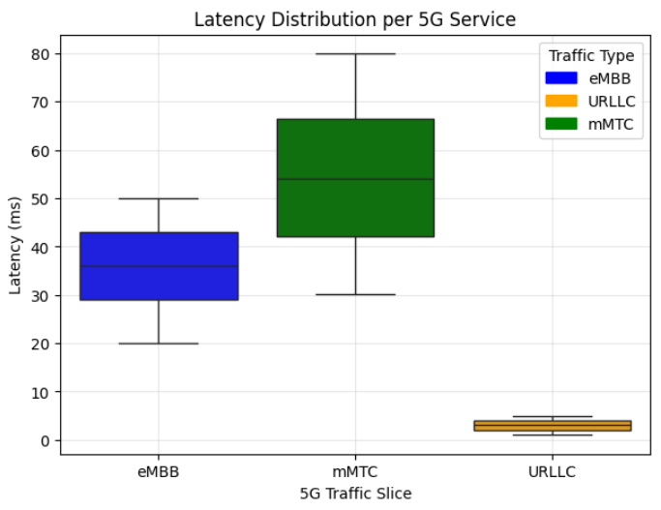
Fig2: Latency distribution per slice

The latency distribution in Fig. 2 follows the expected QoS trends shown in Table 2. URLLC has the lowest latency (2.99 ms) with a narrow spread, reflecting its real-time requirements, supported by moderate throughput and high SINR. eMBB shows moderate latency (35.82 ms) with higher throughput and balanced SINR, while mMTC has the highest latency (54.54 ms) with lower throughput and SINR. The clear separation in the boxplot confirms that the dataset accurately represents QoS differences and realistic 5G traffic behavior.

Table 3: Comparison between public and generated dataset

Model | Dataset | RMSE | MAE
LSTM | Generated | 12.69 | 10.84
 | Public | 32.97 | 27.78
Random Forest | Generated | 11.02 | 7.53
 | Public | 22.29 | 19.16

To further validate the dataset and the proposed approach, both Random Forest and LSTM models were evaluated on the generated dataset and a public dataset, as shown in Table 3. The generated dataset produced lower errors (Random Forest: RMSE = 11.02, MAE = 7.53; LSTM: RMSE = 12.69, MAE = 10.84), while the public dataset showed significantly higher values. This corresponds to roughly a 45–60% increase in error on the public dataset across both models. These results indicate that the public dataset has higher variability and complexity, making prediction more difficult. In contrast, the generated dataset maintains stable QoS patterns, which helps models learn more effectively. The better performance of the LSTM model also shows that the dataset preserves meaningful temporal patterns, supporting accurate and consistent QoS prediction for dynamic 5G scenarios.

Table 4: Model Parameters and Training Configuration

Parameter | Value | Parameter | Value
LSTM Input Features | 4 | Learning Rate (DDQN) | 0.001
Sequence Length | 20 | Discount Factor (γ) | 0.9
LSTM Units | 128 | Exploration Strategy | ε-greedy
GNN Layers | 2 (32 → 16) | Initial ε | 0.45
Graph Type | k-NN (k = 5) | Minimum ε | 0.10
Policy Network (DDQN) | 64 → 32 → 3 | ε Decay | 0.995
Action Space | 3 | Training Epochs | 100
State Input | GNN + LSTM | Batch Size | 16
RMSE | 11.21 | MAE | 7.67

The parameters needed for training and testing the proposed LSTM–GNN–DDQN network is presented in Table 4. The LSTM network uses sequential input features to monitor temporal traffic patterns, while the GNN layers resemble spatial interactions and interference among network nodes. The reinforcement learning component uses an ε-greedy exploration technique with progressive decay to balance exploitation and exploration during training. These parameter values enable reliable performance evaluation, efficient resource allocation decisions, and stable learning for slice-aware radio resource management.

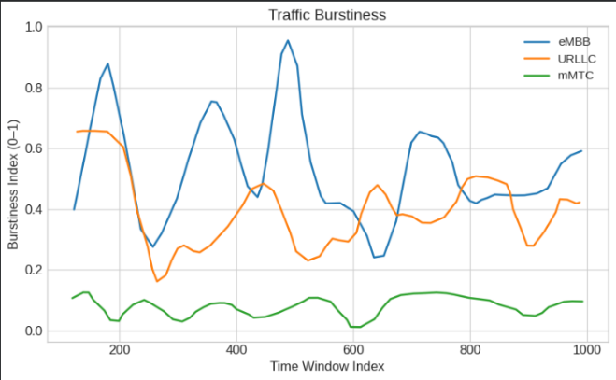
Fig3: Traffic Burstiness of 5G slices in a given time window

The plot in Fig. 3 shows the burstiness of different 5G traffic types over time. eMBB has the highest variation, ranging from about 0.25 to 0.95, reflecting dynamic and bandwidth-heavy applications like video streaming. URLLC shows moderate variation between 0.2 and 0.65, indicating controlled changes suitable for latency-sensitive services. In contrast, mMTC has very low burstiness, mostly below 0.15, showing stable and predictable traffic from IoT devices. These patterns highlight the distinct behavior of each slice, with eMBB being highly dynamic, URLLC relatively stable, and mMTC highly consistent.

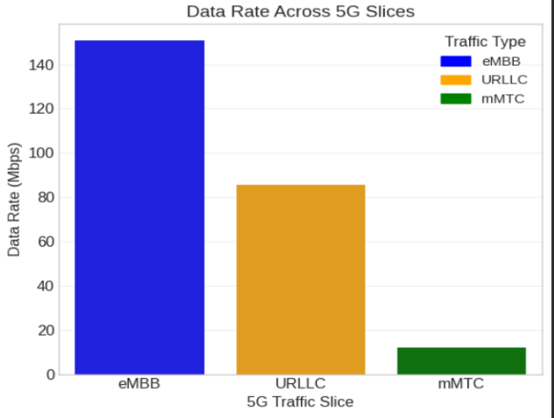
Fig4: Data Rate across 5G slices

The data rate distribution in Fig. 4 highlights the different traffic characteristics of 5G services. eMBB achieves the highest data rate (around 150.65 Mbps), supporting high-bandwidth applications like video streaming. URLLC provides a moderate data rate (about 85.46 Mbps), balancing speed and reliability for latency-sensitive tasks. In contrast, mMTC has a much lower data rate (around 11.97 Mbps), suitable for low-data IoT communication. These differences clearly reflect the specific goals of each traffic type.

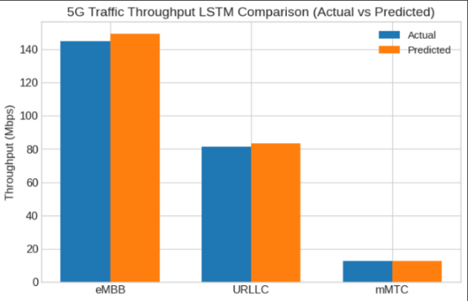
Fig5: LSTM prediction for eMBB throughput

Figure 5 shows that the LSTM model predicts throughput closely matching the actual values across all 5G traffic types. For eMBB, the predicted throughput (~150 Mbps) is very close to the actual (~145 Mbps), showing good learning of high-bandwidth patterns. URLLC also shows accurate prediction, with values (~84 Mbps) close to the actual (~82 Mbps). For mMTC, the predicted (~13 Mbps) closely follows the actual (~12 Mbps) despite lower and stable data rates. Overall, the small difference between actual and predicted values highlights the model’s ability to capture temporal patterns and provide reliable throughput estimates.

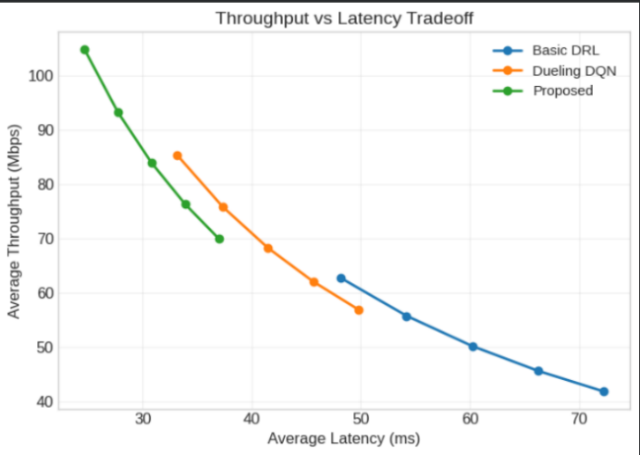
Fig6: Throughput vs. Latency analysis

Combined with the throughput-latency trade shown in Figure 6, where the proposed model operates in a high-throughput and low-latency region, the results demonstrate the effectiveness of the slice-aware DDQN framework for multi-slice radio resource management.

The performance metrics used for evaluating the data are as follows:
Throughput = Total Data Transferred / Total Time
where,
Total Data Transferred = Σ Dataᵢ
Total Time = Σ Timeᵢ

Latency = Total Delay / Number of Packets
where,
Total Delay = Σ (t_{receiveᵢ} − t_{sendᵢ})
N = total number of packets

Packet Loss (%) = (Total Packets Lost / Total Packets Sent) × 100
where,
Packets Lost = Packets Sent − Packets Received

Spectral Efficiency = Total Throughput / Bandwidth
where,
Throughput = Σ Data / Time
Bandwidth = Channel bandwidth (Hz)

Energy Efficiency = Total Throughput / Total Energy Consumption
where,
Total Energy = Σ Energyᵢ

Table 5: Performance comparisons of the proposed algorithms with previous conventional AIML algorithms
Metric | Basic DRL | Dueling DQN | Proposed
Throughput (mbps) | 97.50 | 118 | 144.80
latency (ms) | 2.40 | 1.33 | 0.59
Packet Loss | 51% | 36% | 19%
Spectral Efficiency (bps/Hz) | 1.07 | 1.37 | 1.78
Energy Efficiency (Btu/h per Watt) | 0.85 | 1.1 | 1.41

Table 5 compares the performance of the proposed framework with Basic DRL and Dueling DQN. The proposed model achieves the highest average throughput of 144.80mbps, outperforming both Basic DRL (97.50 mbps) and Dueling DQN (118 mbps). The table also shows lower latency (0.59 ms) and packet loss (19%), indicating better QoS support, especially for latency-sensitive URLLC traffic. In contrast, Basic DRL shows the most latency and packet loss, indicating less efficient scheduling. The proposed approach also improves spectral efficiency (1.78 bps/Hz), and energy efficiency (1.41 Btu/h per Watt) ensuring better bandwidth utilization and balanced resource allocation among slices.
In 5G network slicing scenarios, distributed learning for dynamic radio resource allocation is made possible by the suggested Federated DDQN framework. Only model parameters are shared with the aggregation server in the federated design, as opposed to centralized DRL systems, which permit each base station to train autonomously using its own traffic and channel data. This improves data privacy and drastically lowers transmission overhead. According to simulation results, the proposed approach increases total energy efficiency while keeping strict URLLC latency constraints below 1 ms. The LSTM-based ML traffic prediction enhances proactive resource allocation, while GNN-based architecture simulation improves multi-cell interaction. Compared to standard DQN, the DDQN structure reduces Q-value overestimation and stabilizes convergence. The federated development greatly enhances flexibility in dense 5G deployments.

VI. CONCLUSION

This paper presents an intelligent radio resource management framework for 5G network slicing, supporting eMBB, URLLC, and mMTC services with different QoS requirements. The generated dataset is first validated against typical 5G trends, showing lower prediction errors (RMSE = 12.69, MAE = 7.67) compared to a public dataset. The proposed system combines LSTM-based traffic prediction, GNN-based topology modeling, and a federated multi-agent DDQN approach to enable adaptive and distributed resource allocation under dynamic network conditions. Simulation results demonstrate clear improvements over conventional methods, achieving higher throughput (144.80 Mbps), lower latency (0.59 ms), and reduced packet loss (19%). The model also improves spectral efficiency (1.78) and energy efficiency (1.41), ensuring better resource utilization and balanced performance across slices. The federated setup enhances scalability and privacy through local training, while DDQN improves learning stability and decision accuracy. These results reflect realistic 5G slice behavior, confirming the validity of the dataset. Overall, the proposed framework provides an efficient, scalable, and practical solution for next-generation wireless networks.

VII. ACKNOWLEDGEMENT

We express our sincere gratitude to SRM Institute of Science and Technology for providing the necessary infrastructure and resources at the SRM Centre for NextGen Communication Research and Applications (CeNCRA) which played a crucial role in conducting this research.

REFERENCES

- A. Filali, Z. Mlika, S. Cherkaoui, and A. Kobbane, “Dynamic SDN-based Radio Access Network slicing with deep reinforcement learning for URLLC and eMBB services,” IEEE Trans. Network and Service Management, vol. 19, no. 2, pp. 1–14, 2022.

- R. M. Sohaib, Y. Sambo, O. Onireti, R. Swash, S. Ansari, and M. A. Imran, “Intelligent resource management for eMBB and URLLC in 5G and beyond wireless networks,” IEEE Communications Surveys & Tutorials, vol. 25, no. 2, pp. 1–33, 2023.

- H. Wang, Y. Wu, G. Min, and W. Miao, “A graph neural network-based digital twin for network slicing management,” IEEE Internet of Things Journal, vol. 10, no. 12, pp. 1–14, 2023.

- D. Shome and A. Kudeshia. “Deep Q-learning for 5G network slicing with diverse resource stipulations and dynamic data traffic,” in Proc. IEEE Int. Conf. Artificial Intelligence in Information and Communication, 2021, pp. 1–6.

- D. Kulkarni, M. Venkatesan, and A. V. Kulkarni, “Deep learning traffic prediction and resource management for 5G RAN slicing,” Wireless Personal Communications, vol. 122, pp. 1–20, 2022.

- F. Lotfi and F. Afghah, “Open RAN LSTM traffic prediction and slice management using deep reinforcement learning,” in Proc. IEEE Global Communications Conference (GLOBECOM), 2022, pp. 1–6.

- T. Perera, S. Atapattu, Y. Fang, P. Dharmawansa, and J. Evans, “Flex-Net: A graph neural network approach to resource management in flexible duplex networks,” IEEE Trans. Wireless Communications, vol. 22, no. 4, pp. 1–15, 2023.

- H. Wang, Y. Wu, G. Min, and W. Miao, “A graph neural network-based digital twin for network slicing management,” IEEE Internet of Things Journal, vol. 10, no. 12, pp. 1–14, 2023.

- G. Chen, R. Shao, F. Shen, and Q. Zeng, “Slicing resource allocation based on dueling DQN for eMBB and URLLC hybrid services in heterogeneous integrated networks,” Sensors, vol. 23, no. 5, pp. 1–18, 2023.

- H. Zhuo, W. Feng, Y. Lin, Q. Xu, and Q. Yang, “Federated deep reinforcement learning for distributed resource allocation,” IEEE Trans. Neural Networks and Learning Systems, vol. 33, no. 10, pp. 1–12, 2022.

- H. M. F. Noman, K. Dimyati, K. A. Noordin, E. Hanafi, and A. Abdrabou, FeDRL-D2D: Federated deep reinforcement learning empowered resource allocation scheme for energy efficiency maximization in D2D-assisted 6G networks,” IEEE Access, vol. 11, pp. 1–18, 2023.

- Y. Usman, H. Oladipupo, A. D. During, R. Akl, and R. Chataut, “AI, ML, and LLM integration in 5G/6G networks: A comprehensive survey of architectures, challenges, and future directions,” IEEE Access, vol. 11, pp. 1–30, 2023.

- I. A. Bartsiokas, P. K. Gkonis, D. I. Kaklamani, and I. S. Venieris, “ML-based radio resource management in 5G and beyond networks: A survey,” IEEE Communications Surveys & Tutorials, vol. 24, no. 4, pp. 1–28, 2022.

